**TEAM: TECH TITANS**

**WILDLIFE PROCETION USINNG RFID**

**PROBLEM STATEMENT:**

The increasing incidence of animals succumbing to train accidents poses a critical challenge that demands immediate attention. These unfortunate incidents not only result in harm to wildlife populations but also raise concerns about railway safety. Developing effective strategies to reduce animal fatalities in train accidents is imperative to promote coexistence between transportation infrastructure and the natural environment

**BLOCK DIAGRAM:**

GSM

LORAWAN

Arduino UNO

POWER SUPPLY

RFID

cloud

**HARDWARE AND SOFTWARE SPECIFICATION:**

**Hardware:**

* Arduino UNO (5 -12V)
* GSM Module (800L) (3.3-5V)
* RFID Tag (860-960 MHz,10m)
* LoRA WAN LPS8N

**Software:**

* Arduino IDE (Embedded C)

**DATA SURVEY:**

**Railway tracks in forest area:**

India has the 4th largest railway system in the world, behind only US, Russia and China.

The Indian Railways consists of a total track length of 126,366 km with 7,335 stations.

Our analysis suggests that 6165 km railway length passes through already forest area.

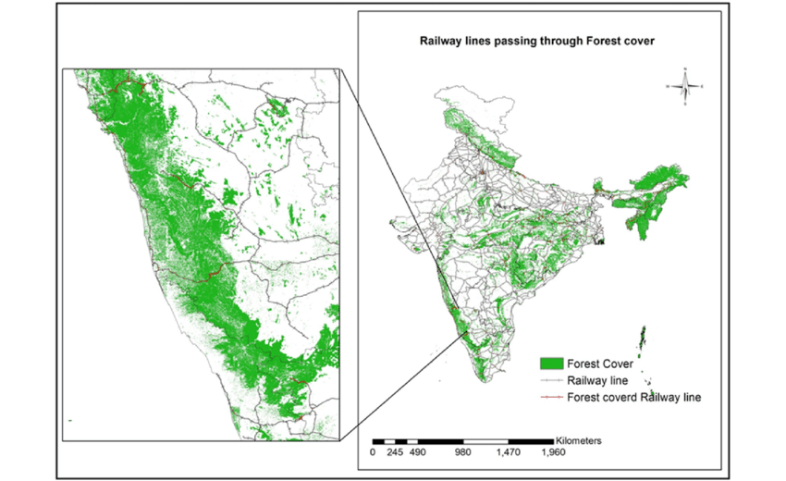

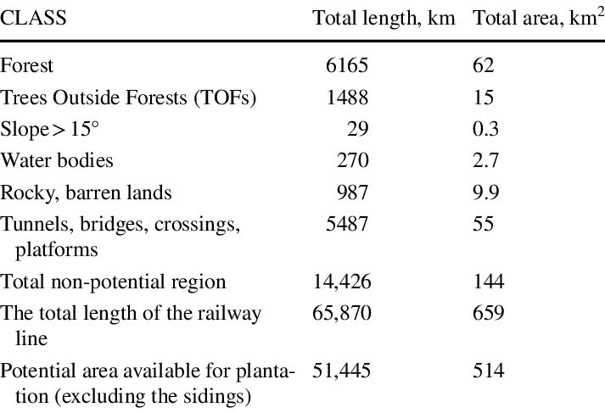

**Impact on animals:**

The Railways witnessed 31 animal deaths per day for four years and also, the Ministry of Railways has provided data on the number of animal deaths in train accidents.

More than 35000 animals died in train accidents in the last three and a half years.

On an average, 20 elephants are killed in train accidents every year, according to Indian government data.

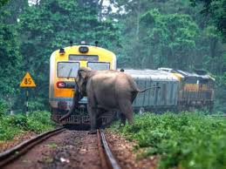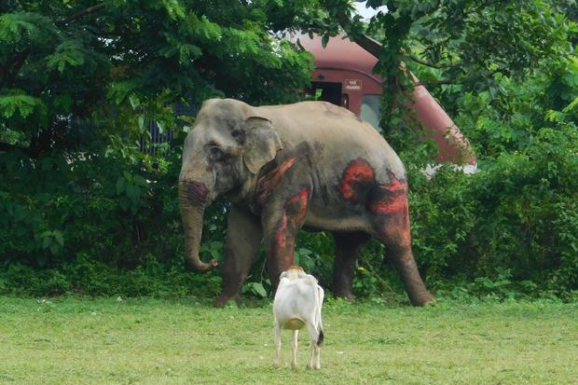

**HISTORICAL ACCIDENT ANALYSIS**

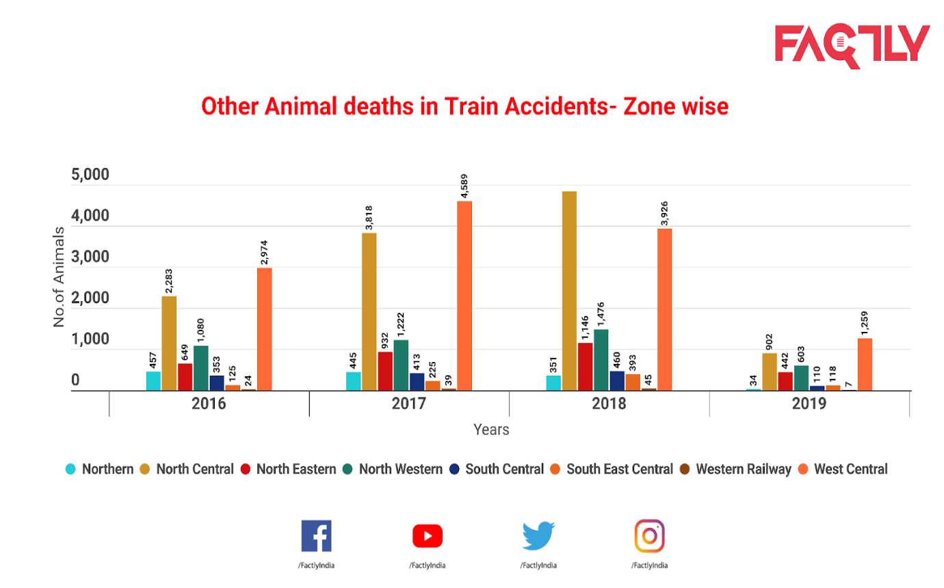

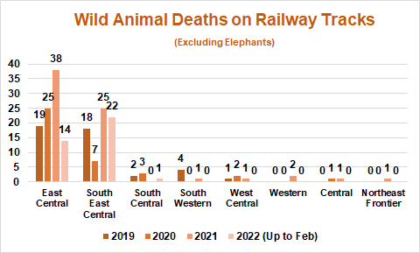

* Over 63,000 animals, including four Asiatic lions and 73 elephants, died on railway tracks between 2017-18 to 2020-21
* 45 Elephants, 150 Wild Animals Killed After Being Hit By Trains Between 2019-21,
* As many as 934 people were arrested and fined in these cases. According to Railway Ministry data, 1,01,924 cattle died in train accidents between 2019-20 to 2022-23 (up to 23 January 2023).
* In November 2023, three elephants were killed by a train in eastern India's West Bengal state. In August, a pregnant elephant and two others were killed by another train in the same region.

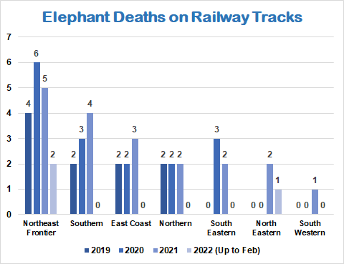

**RECENT ACCIDENTS SURVEY**

The 9-month-old elephant, which rescuers have named Bani (Mother Earth), was hit by a speeding train near Corbett National Park in northern India in mid-December, leaving her seriously injured and paralyzed. Bani's mother, who was pregnant at the time, died in the same accident.

The story of Bani and her mother is not a rare one in India, which is home to more than 20,000 wild elephants, or about 60% of the overall wild Asian elephant population. In November 2023, three elephants were killed by a train in eastern India's West Bengal state. In August, a pregnant elephant and two others were killed by another train in the same region.

On an average, 20 elephants are killed in train accidents every year, according to Indian government data. The deaths usually happen when elephant’s cross railway lines that run through their habitats. India has lost about 200 elephants over the last decade to train accidents alone, and that's in addition to high number of deaths from poaching and accidental electrocutions.

The domestic population of elephants, which are India's national heritage animal, has dropped dramatically over the last century from 1 million to the current 20,000. That's ringing alarm bells over the wider biodiversity of India's forests, as elephants play a crucial role in ecosystems and food chains.

"They are called the farmers of the forest," said Satyaranayan. "Loss of elephants will eventually affect everything, from agriculture to livelihoods."

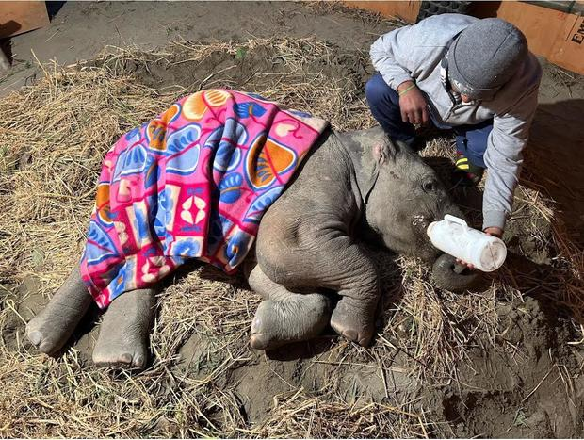

**RFID EVALUATION IN COMPARISION TO INTERNATIONAL INITIATIVES:**

RFID technology is used for animal detection and tracking in various countries around the world for a variety of purposes, including livestock management, wildlife conservation, and pet identification. Some countries that use RFID for animal tracking include :

1. **Livestock Management:** RFID tags are commonly used in countries like the United States, Australia, and European nations for tracking and managing livestock, such as cows, sheep, and pigs. This helps in identifying individual animals, monitoring their health, and improving breeding practices.

2. **Pet Identification:** Many countries, including the US, UK, Canada, and Australia, use RFID tags for identifying and tracking pets like dogs and cats. This helps in reuniting lost pets with their owners and ensuring they receive proper care.

3. **Wildlife Conservation:** In countries like South Africa and India, RFID technology is used for tracking and monitoring endangered species to help in conservation efforts and prevent illegal poaching.

4. **Fisheries Management:** Countries with active fisheries, such as Norway, Japan, and Iceland, use RFID tags to track fish populations, monitor migration patterns, and prevent illegal fishing practices.

**NATIONAL IMPLEMENTATION SURVEY:**

* **United States:** Used for tracking livestock such as cattle and sheep to monitor movement, health, and breeding patterns.
* **Australia:** Implemented for wildlife conservation efforts, such as tracking endangered species and monitoring migration patterns of animals like birds and marine species.
* **New Zealand:** Utilized for both livestock management and conservation purposes, tracking animals like deer, cows, and endangered species for research and management.
* **United Kingdom:** Employed for pet identification, ensuring lost pets can be returned to their owners quickly and efficiently.

These are just a few examples, as RFID technology is increasingly being adopted worldwide for animal tracking due to its efficiency and accuracy in monitoring and managing animal populations. Overall, RFID technology plays a crucial role in animal detection and tracking for various purposes, ranging from livestock management to wildlife conservation and fisheries management.

As per research gate, Australia is using RFID for monitoring endangered species.

Qur project will be the pioneer in using RFID for wildlife monitoring along the railway tracks and store their migratory path. This project helps to keep data of all the animals in the cloud and reduces the ned for surveys..

**TECHNOLOGIES USED:**

The technologies that we have used in this project are

IOT- Internet of Things

Embedded systems

Cloud computing

Webpage development